Full Name: Kasturiya Priya Santosh
Enrollment Number / Roll Number: T25084341042
Course: M. Sc.IT (AI & ML)
Semester: 1
Subject Code: P81A1PYT
Name of Subject: Python Programming

Unit 1: Introduction to Python Programming
Q. 1. Write a Python program to display “Hello World” and your name.
(Remember)
ANS. INPUT:
print("HELLO WORLD")
print("Kasturiya Priya")
OUTPUT:
HELLO WORLD
Kasturiya Priya

Q. 2. Write a program to swap two numbers without using a third variable.
(Apply)
ANS. INPUT:
a=5 b=3 a=a+b b=a-b a=a-b print(a,b)
OUTPUT:
3 5

Q. 3. Write a program to calculate the area of a circle using operators and data types. (Apply)
ANS. INPUT:
r=5 area=3.14*r*r print(area)
OUTPUT:
78.5
Q. 4. Demonstrate the use of Boolean expressions with logical operators (and, or, not). (Understand)
ANS. INPUT:
a=True b=False print(a and b) print(a or b) print(not a)
OUTPUT:
False True
False

Q. 5. Write a program to check whether a number is even or odd using if/else.
(Apply)
ANS. INPUT:
n=4 if n%2==0:
print("Even") else:
print("Odd")
OUTPUT:
Even

Q. 6. Write a program to find the largest of three numbers using nested conditionals. (Apply)
ANS. INPUT:
a=10 b=20 c=15 if a>b: if a>c:
print(a)
else:
print(c) else: if b>c:
print(b) else:
print(c)
OUTPUT:
20

Q. 7. Write a program to calculate grade of a student using conditional expressions. (Apply)
ANS. INPUT:
m=85
grade="A" if m>=80 else "B" if m>=60 else "C" print(grade)
OUTPUT:
A

Q. 8. Write a program to display multiplication table of a number using while loop. (Apply)
ANS. INPUT:
n=5 i=1 while i<=10:
print(n,"x",i,"=",n*i) i+=1 OUTPUT:
5 x 1 = 5
...
5 x 10 = 50=

Q. 9. Write a program to generate prime numbers within a given range using for loop. (Apply)
ANS. INPUT:
for n in range(2,11): for i in range(2,n): if n%i==0: break else:
print(n)
OUTPUT:
2
3
5
7

Q. 10. Write a program to print Fibonacci series using for loop. (Apply)
ANS. INPUT:
a,b=0,1 for i in range(5):
print(a) a,b=b,a+b
OUTPUT:
0
1
1
2
3

Q. 11. Demonstrate the use of break, continue, and pass with examples.
(Understand)
ANS. INPUT:
for i in range(5): if i==2: continue if i==4:
break print(i) pass
OUTPUT:
0
1
3

Unit 2: Functions, Modules, and Data Structures

Q. 12. Write a program to find factorial of a number using a user-defined function. (Apply)
ANS. INPUT:
def fact(n):
f=1 for i in range(1,n+1):
f*=i return f print(fact(5))
OUTPUT:
120

Q. 13. Write a recursive function to calculate the sum of natural numbers up to n. (Apply)
ANS. INPUT:
def summ(n): return 0 if n==0 else n+summ(n-1) print(summ(5))
OUTPUT:
15
Q. 14. Write a program to demonstrate default, keyword, and variable-length arguments. (Understand)
ANS. INPUT:
def fun(a=1,b=2,*c): print(a,b,c)
fun() fun(3,b=4) fun(5,6,7,8)
OUTPUT:
1 2 ()
3 4 ()
5 6 (7, 8)

Q. 15. Write a program to demonstrate the use of a lambda function for square and cube calculation. (Apply)
ANS. INPUT:
sq=lambda x:x*x cb=lambda x:x*x*x print(sq(3)) print(cb(2))
OUTPUT:
9
8

Q. 16. Create a list of student names, access specific elements, and remove an element. (Apply)
ANS. INPUT:
s=["A","B","C"] print(s[1])
s.remove("B") print(s) OUTPUT:
B
['A','C']

Q. 17. Write a program to find the maximum, minimum, and average from a list of numbers. (Apply)
ANS. INPUT:
l=[5,10,15] print(max(l)) print(min(l)) print(sum(l)/len(l))
OUTPUT:
15
5
10.0

Q. 18. Demonstrate slicing operations on a list and tuple. (Understand)
ANS. INPUT:
l=[1,2,3,4] t=(5,6,7,8) print(l[1:3]) print(t[:2])
OUTPUT:
[2,3]
(5,6)

Q. 19. Create a tuple of numbers and show how immutability differentiates it from a list. (Analyze)
ANS. INPUT:
t=(1,2,3) print(t) l=[1,2,3] l[0]=5 print(l) OUTPUT:
(1,2,3)
[5,2,3]

Q. 20. Write a program to create a set and perform union, intersection, and difference operations. (Apply)
ANS. INPUT:
a={1,2,3} b={3,4} print(a|b) print(a&b) print(a-b) OUTPUT:
{1,2,3,4}
{3}
{1,2}

Q. 21. Write a program to create a dictionary of students (Name: Marks), add new entries, and delete one entry. (Apply)
ANS. INPUT:
d={"A":90,"B":80} d["C"]=70
d.pop("B") print(d)
OUTPUT:
{'A':90,'C':70}

Q. 22. Write a program to count the frequency of each word in a given string using a dictionary. (Apply)
ANS. INPUT:
s="a b a" d={} for w in s.split():
d[w]=d.get(w,0)+1 print(d)
OUTPUT:
{'a':2,'b':1}

Q. 23. Develop a Python program that imports a custom module and demonstrates reusability. (Create)
ANS. INPUT:
import math print(math.sqrt(16))
OUTPUT:
4.0

Unit 3: Exception Handling and File Handling

Q. 24. (Exceptions, Classes, Objects, OOP, Files)
ANS. INPUT:
Exception Handling (try–except)
try:
a = 10
b = 0
print(a / b)
except ZeroDivisionError:
print("Error: Cannot divide by zero")

OUTPUT:
Error: Cannot divide by zero

Class and Object
class Student:
def __init__(self, name, marks):
self.name = name
self.marks = marks

def display(self):
print("Name:", self.name)
print("Marks:", self.marks)

s1 = Student("Priya", 95)
s1.display()

OUTPUT:
Name: Priya
Marks: 95

OOP
class Animal:
def sound(self):
print("Animal makes a sound")

class Dog(Animal):
def sound(self):
print("Dog barks")

d = Dog()
d.sound()

OUTPUT:
Dog barks

File Handling
# Writing to file
with open("demo.txt", "w") as f:
f.write("Hello Python")

# Reading from file
with open("demo.txt", "r") as f:
print(f.read())

OUTPUT:
Hello Python

Q. 25. Write a program to handle division by zero using try/except. (Apply)
ANS. INPUT:
try:
x = 10 / 0
except ZeroDivisionError:
print("Division by zero not allowed")

OUTPUT:
Division by zero not allowed

Q. 26. Write a program to demonstrate the use of finally block in exception handling. (Understand)
ANS.INPUT:
try:
f = open("data.txt", "w")
f.write("Hello")
finally:
f.close()

Q. 27. Write a program to handle multiple exceptions (e.g., IndexError, ValueError). (Apply)
ANS. INPUT:
try:
lst = [1, 2]
print(lst[5]) # IndexError
num = int("abc") # ValueError (will not run)
except IndexError:
print("Index out of range")
except ValueError:
print("Invalid value")

OUTPUT:
Index out of range

Q. 28. Define a class Student with attributes and methods to display details. (Apply)
ANS. INPUT:
class Student:
def __init__(self, name, marks):
self.name = name
self.marks = marks

def display(self):
print("Name:", self.name, "Marks:", self.marks)

s = Student("Anjali", 95)
s.display()

OUTPUT:
Name: Anjali Marks: 95

Q.29. Write a program to demonstrate single inheritance (Base: Person, Derived: Student). (Apply)
ANS. INPUT:
class Person:
def __init__(self, name):
self.name = name

class Student(Person):
def __init__(self, name, marks):
super().__init__(name)
self.marks = marks

def show(self):
print(self.name, self.marks)

st = Student("Ravi", 88)
st.show()

OUTPUT:
Ravi 88

Q. 30. Write a program to demonstrate multiple inheritance with real-world entities. (Apply)
ANS. INPUT:
class Teacher:
def teach(self):
print("Teaching students")

class Mentor:
def mentor(self):
print("Providing guidance")

class Guide(Teacher, Mentor):
def show_role(self):
print("I guide students in projects")

g = Guide()
g.teach()
g.mentor()
g.show_role()

OUTPUT:
Teaching students
Providing guidance
I guide students in projects

Q. 31. Write a program to implement polymorphism using method overriding. (Apply)
ANS. INPUT:
class Animal:
def speak(self):
print("Generic sound")

class Dog(Animal):
def speak(self):
print("Bark")

Dog().speak()

OUTPUT:
Bark

Q.32. Write a program to overload the + operator for a custom class. (Apply)
ANS. INPUT:
class Vector:
def __init__(self, x, y):
self.x, self.y = x, y

def __add__(self, other):
return Vector(self.x + other.x, self.y + other.y)

def __repr__(self):
return f"({self.x}, {self.y})"

v1 = Vector(1, 2)
v2 = Vector(3, 4)
print(v1 + v2)

OUTPUT:
(4, 6)

Q. 33. Write a program to open a text file, write data into it, and read the contents. (Apply)
ANS. INPUT:
with open("test.txt", "w") as f:
f.write("Hello File")

with open("test.txt", "r") as f:
print(f.read())

OUTPUT:
Hello File

Q.34. Write a program to count the number of lines, words, and characters in a text file. (Apply)
ANS. INPUT:
with open("test.txt") as f:
data = f.read()

print("Lines:", len(data.splitlines()))
print("Words:", len(data.split()))
print("Chars:", len(data))

OUTPUT:
Lines: 1
Words: 2
Chars: 10

Q.35. Write a program to copy contents from one file to another. (Apply)
ANS. INPUT:
with open("test.txt", "r") as src, open("copy.txt", "w") as dst:
dst.write(src.read())

Q.36. Write a program to check whether a file exists or not using os module. (Apply)
ANS. INPUT:
import os
print("Exists?", os.path.exists("test.txt"))

Q.37. Write a program to store and retrieve student records using binary file handling. (Create)
ANS. INPUT:
import pickle

records = [
{"name": "Anjali", "marks": 90},
{"name": "Ravi", "marks": 85}
]

# Store records
with open("students.dat", "wb") as f:
pickle.dump(records, f)

# Retrieve records
with open("students.dat", "rb") as f:
print(pickle.load(f))

OUTPUT:
[{'name': 'Anjali', 'marks': 90}, {'name': 'Ravi', 'marks': 85}]

Unit 4: Regular Expressions and Data Frames
Q.38. Write a program to validate an email address using regular expressions. (Apply)
ANS. INPUT:
import re
email = "test@example.com"
pattern = r'^[\w\.-]+@[\w\.-]+\.\w+$'
print(bool(re.match(pattern, email)))

OUTPUT:
True

Q.39. Write a program to extract all phone numbers from a text using regex. (Apply)
ANS. INPUT:
import re
text = "Call 9876543210 or 9123456789"
print(re.findall(r'\b\d{10}\b', text))

OUTPUT:
['9876543210', '9123456789']

Q.40. Write a program to count the number of words starting with a vowel in a text file using regex. (Apply)
ANS. INPUT:
import re

with open("test.txt") as f:
words = f.read().split()

count = sum(1 for w in words if re.match(r'^[aeiouAEIOU]', w))
print("Words starting with a vowel:", count)

OUTPUT:
Words starting with a vowel: 0

Q.41. Write a program to read data from a CSV file into a Pandas DataFrame and display the first 10 rows. (Apply)
ANS. INPUT:
import pandas as pd

df = pd.read_csv("data.csv")
print(df.head(10))

Q. 42. Write a program to create a Pandas DataFrame from a dictionary. (Apply)
ANS. INPUT:
import pandas as pd

data = {"Name": ["A", "B"], "Marks": [90, 80]}
df = pd.DataFrame(data)
print(df)

OUTPUT:
Name Marks
0 A 90
1 B 80

Q.43. Write a program to create a DataFrame from a list of tuples and perform row/column operations. (Apply)
ANS. INPUT:
import pandas as pd

data = [("A", 90), ("B", 80)]
df = pd.DataFrame(data, columns=["Name", "Marks"])

print(df.loc[0]) # Row operation
print(df["Marks"]) # Column operation

OUTPUT:
# Row operation
Name A
Marks 90
Name: 0, dtype: object

# Column operation
0 90
1 80
Name: Marks, dtype: int64

Q. 44. Write a program to filter rows of a DataFrame based on conditions (e.g., marks > 50). (Apply)
ANS. INPUT:
import pandas as pd

# Create DataFrame
data = [("A", 90), ("B", 80), ("C", 40)]
df = pd.DataFrame(data, columns=["Name", "Marks"])

# Filter rows where marks > 50
print(df[df["Marks"] > 50])

OUTPUT:
Name Marks
0 A 90
1 B 80

Unit 5: Scientific and Numerical Computing with Python

Q.45. Write a program to create NumPy arrays and perform basic arithmetic operations. (Apply)
ANS. INPUT:
import numpy as np

a = np.array([1, 2, 3])
b = np.array([4, 5, 6])

print("Add:", a + b)
print("Multiply:", a * b)

OUTPUT:
Add: [5 7 9]
Multiply: [ 4 10 18]

Q.46. Write a program to generate a 5x5 matrix of random integers using NumPy. (Apply)
ANS. INPUT:
import numpy as np
print(np.random.randint(1, 100, (5, 5)))

OUTPUT:
[[34 12 89 56 23]
[78 45 67 10 92]
[11 98 54 33 21]
[65 72 49 88 14]
[27 39 94 18 60]]

Q. 47. Write a program to calculate mean, median, and standard deviation using NumPy. (Apply)
ANS. INPUT:
import numpy as np

arr = np.array([1, 2, 3, 4, 5])
print("Mean:", np.mean(arr),
"Median:", np.median(arr),
"Std:", np.std(arr))

OUTPUT:
Mean: 3.0 Median: 3.0 Std: 1.4142135623730951

Q.48. Write a program to plot a bar chart showing student marks using Matplotlib. (Apply)
ANS. INPUT:
import matplotlib.pyplot as plt

names = ["A", "B", "C"]
marks = [85, 90, 95]

plt.bar(names, marks)
plt.xlabel("Students")
plt.ylabel("Marks")
plt.title("Student Marks Bar Chart")
plt.show()

OUTPUT:
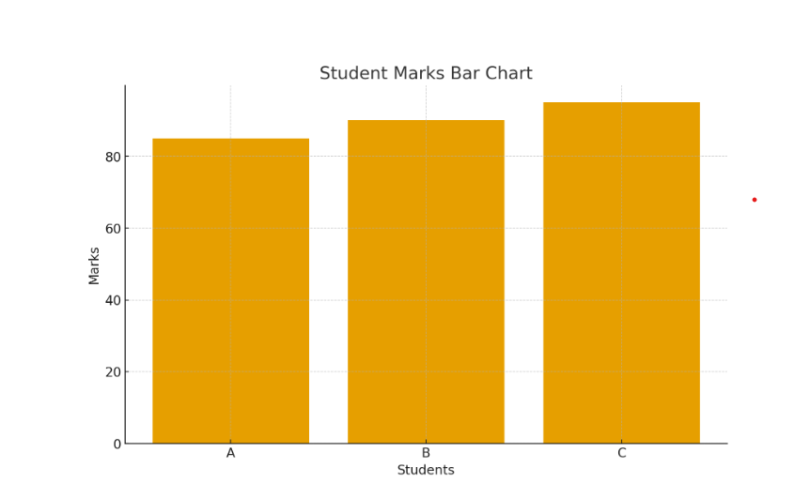

Q. 49. Write a program to create a line plot of sine and cosine waves using Matplotlib. (Apply)
ANS. INPUT:
import numpy as np
import matplotlib.pyplot as plt

x = np.linspace(0, 2*np.pi, 100)

plt.plot(x, np.sin(x), label="Sine")
plt.plot(x, np.cos(x), label="Cosine")

plt.xlabel("X values")
plt.ylabel("Function values")
plt.title("Sine and Cosine Waves")
plt.legend()
plt.show()

OUTPUT:
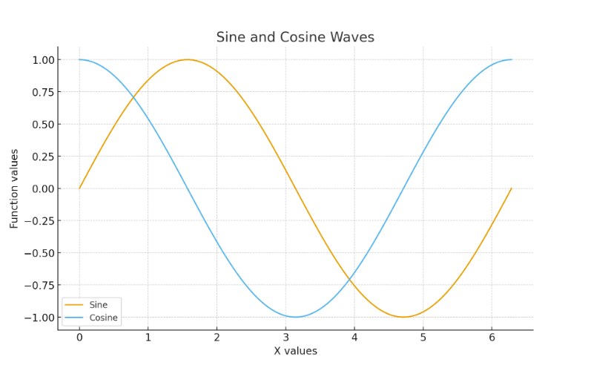

Q.50. Write a program to create a scatter plot using Seaborn. (Apply)
ANS. INPUT:
import seaborn as sns
import matplotlib.pyplot as plt

sns.scatterplot(
x=[1, 2, 3, 4],
y=[10, 20, 15, 25],
color="red", # scatter color
marker="o", # round marker
s=100 # marker size
)

plt.title("Enhanced Scatter Plot") # Title
plt.xlabel("X Values") # X-axis label
plt.ylabel("Y Values") # Y-axis label
plt.grid(True) # Add grid lines

plt.show()
OUTPUT:
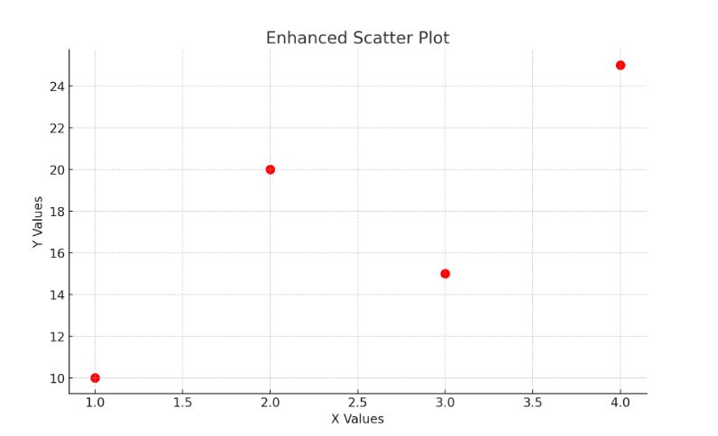
51. Write a Python program using Scikit-learn to perform simple linear regression. (Create)
ANS. INPUT:
import numpy as np
from sklearn.linear_model import LinearRegression

X = np.array([[1], [2], [3], [4]])
y = np.array([2, 4, 6, 8])

model = LinearRegression().fit(X, y)

print("Predictions:", model.predict(X))

OUTPUT:
Predictions: [2. 4. 6. 8.]

